Exercises – Semantic Tableaux Method
Exercise 1.
Using the semantic tableaux method decide what kind (consistent, inconsistent, valid) of a formula is
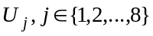. If is consistent, find all its models.
- ; 2. 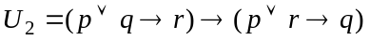;
- 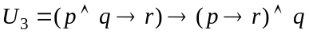; 4. 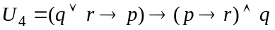;
5. ; 6. ;
- 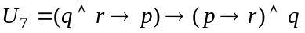; 8. .
Exercise 2.
Prove that the following formulas are tautologies using the semantic tableaux method:
- distribution of ’’ over ’’: ;
- separation of the premises law: 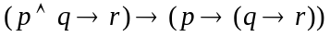;
- distribution of ’’ over ’’: ;
- distribution of ’’ over ’’: ;
- reunion of the premises law: 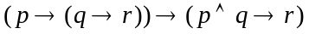;
- distribution of implication:;
- distribution of ’’ over ’’: .
- permutation of the premises law: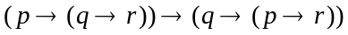;
Exercise 3.
Using the semantic tableaux method, decide whether the following logical consequences hold or not.
If a logical consequence does not hold find an anti-model of it.
- 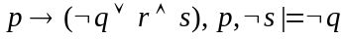 2.
3. 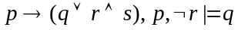 4. 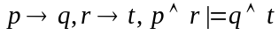
5. 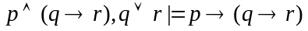 6.
- 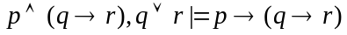 8. 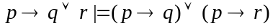
Exercise 4.
Write all the anti-models of the propositional formulas 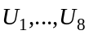 using the semantic tableaux method.
- 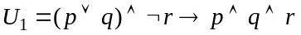; 2. 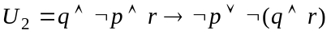;
3. 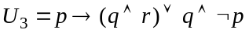; 4. 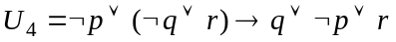;
- 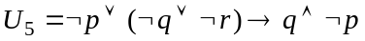; 6. 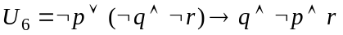;
7. 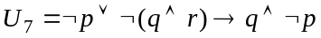; 8. .
Exercise 5.
Using the semantic tableaux method, prove the following properties in predicate logic:
- ’’ is semi-distributive over ’’:
and

- ’’ is semi-distributive over ’’:
and

- ’’ is semi-distributive over ’’:
and

- ’’ is semi-distributive over ’’ :
and

- and
- ’’ is distributive over ’’

- ’’ is distributive over ’’

Exercise 6.
Check the validity of the following first-order formulas using the semantic tableaux method:
- ; 2. ;
- ; 4. ;
- ; 6. ;
- ; 8. .
Exercise 7.
Using the semantic tableaux method check whether the following logical consequences hold or not.
- ;
- ;
- ;
- ;
- ;
- ;
- .
Exercise 8.
Hypotheses:
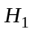. If it is sunny, Diane and Alice go to the swimming pool.
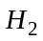. Ben goes to the swimming pool on Thursdays.
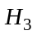. It was sunny last Thursday.
Conclusion: . Did Diane meet Ben at the swimming pool last Thursday?

Prove the following logical consequence 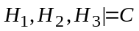using the semantic tableaux method.
Exercise 9.
Hypotheses:
. All hummingbirds are richly colored.
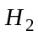. No large birds live on honey.
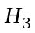. Birds that do not live on honey are dull in color.
Conclusion:. All hummingbirds are small.

Check whether the following logical consequence holds
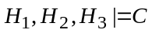 using the semantic tableaux method.

